**How to Install Windows 10 on a New Hard Drive with USB Full Tutorial**

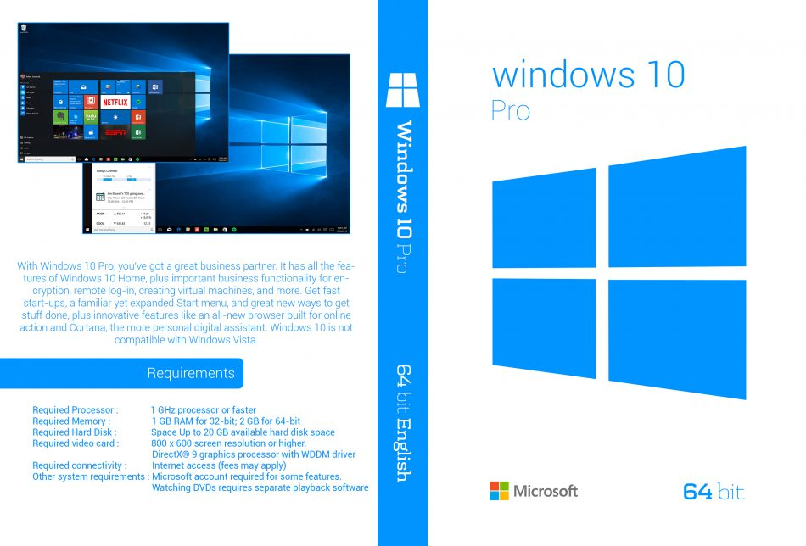

* This guide demos how to install Windows 10 on a new hard drive with pictures. It provides a complete step-by-step you need to install Windows 10 on a new hard drive from a USB.

**Steps to Install Windows 10 on a New Hard Drive**

Here are the high-level steps covered in this guide:

1. Get what you need to Install Windows 10
2. Create a Windows 10 Bootable USB Drive
3. Confirm that your PC meets then requirements to Install Windows 10
4. Configure Boot Sequence to Boot from USB
5. Perform Windows 10 Install on a New Hard Drive
6. Complete Windows 10 Post Install
7. Get what you need to Install Windows 10 on a New Hard Drive

To install Windows 10 on a hard drive you need the following:

1. Window 10 ISO file
2. Valid Windows 10 key (Home, Pro or Enterprise) *(Also you can active window with Microsoft account)
3. A PC that meets the Windows 10 installation requirements (See Step 3 below)
4. Create a Windows 10 Installation Bootable USB

* The first step to install Windows 10 on a new hard drive is to create a Windows 10 Bootable USB.
* If you already have a Windows 10 installation Bootable USB [proceed to the next step.](https://www.itechguides.com/how-to-install-windows-10-step-by-step-with-pictures/?preview=true&_thumbnail_id=4011#Confirm_that_Your_PC_Meets_Requirements_to_Install_Windows_10_on_a_New_Hard_Drive)
* If you need to create an installation Bootable USB, here are the steps:
* [Download Windows 10 ISO with Media Creation Tool.](https://www.itechguides.com/download-windows-10-iso/)
* **Scan QR** to Download Media Creation Tool



* After downloading the ISO file, insert a USB into your PC. and create bootable USB with using Rufus.
* **Scan QR** to learn how to Create Bootable USB



3. Confirm that Your PC Meets Requirements to Install Windows 10 on a New Hard Drive

* If you attempt to install Windows 10 on a PC that do not meet the minimum installation requirement, the installation is likely to fail.

To ensure your PC meets the requirement review the following information.

* Below are the Windows 10 minimum installation requirements:

1. Processor: 1 gigahertz (GHz) or faster processor or SoC
2. RAM: 1 gigabyte (GB) for 32-bit Windows 10 or 2 GB for 64-bits
3. Hard disk space: 16 GB for 32-bit OS 20 GB for 64-bit OS
4. Graphics card: DirectX 9 or later with WDDM 1.0 driver
5. Display: 800×600

* Here are my recommended requirements for maximum performance:

1. Processor: 2.5 GHz Dual Core minimum (faster processor is better)
2. RAM: 4 gigabyte (GB) for 32-bit or 8 GB for 64-bit
3. Hard disk space: 320 GB (or more)
4. Graphics card: DirectX 9 or later with WDDM 1.0 driver (Any modern graphics card should do)
5. Display: 1920X1080 (Full HD)
6. Your Configure Boot Sequence to Boot from USB

* You need enter BIOS menu of your PC to configure boot sequence.
* How to enter BIOS menu and configure boot order **Scan this QR**



* After you will display windows installation setup

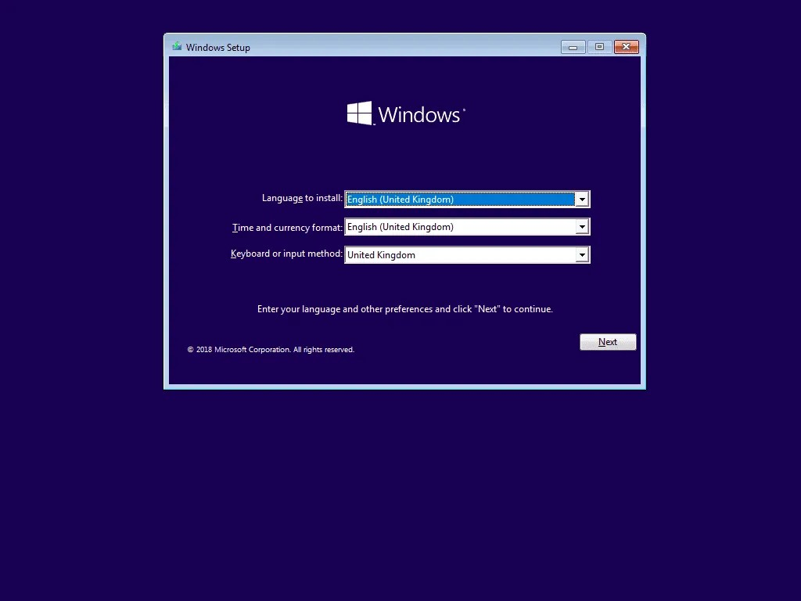

* At the install screen, click **Install now**.

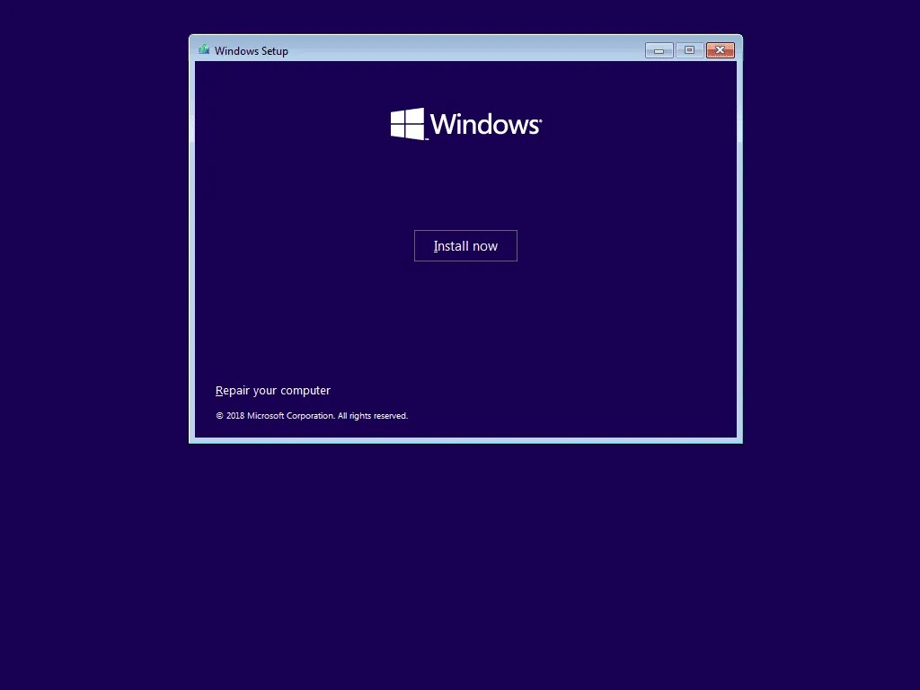

* When Activate Windows screen loads, type your product key and click Next.

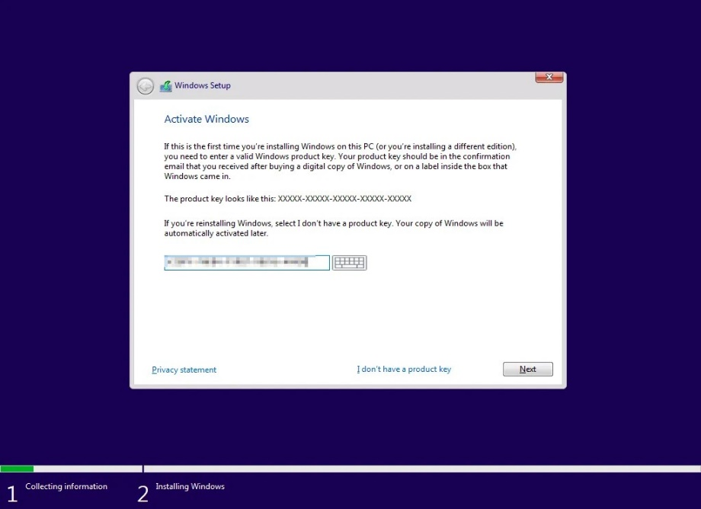

If you do not provide a valid product key, you have up to 180 days to evaluate Windows 10 – then you will be required to register a product key.

* At **Applicable notices and licence terms** screen, check **I accept the licence terms**. Then click Next.

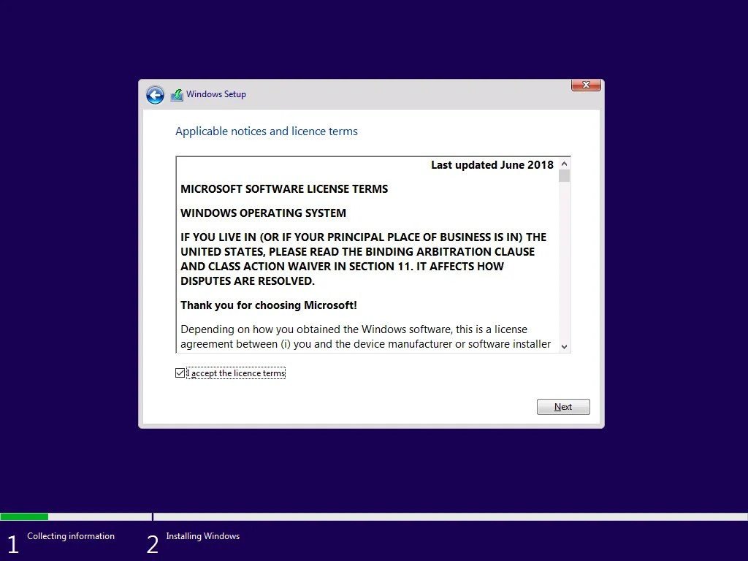

* Then select **Custom: Install Windows only (advanced)**.

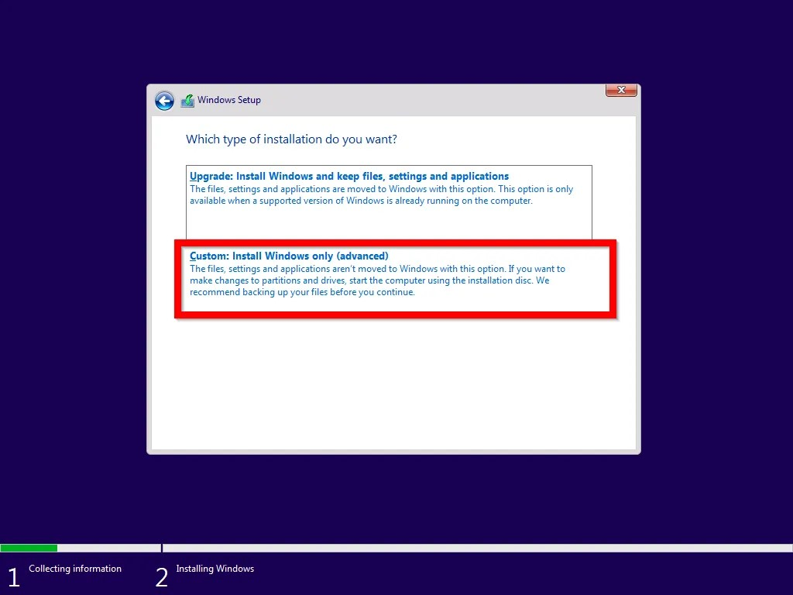

* Then select the hard drive you wish to install the OS and click **Next**.

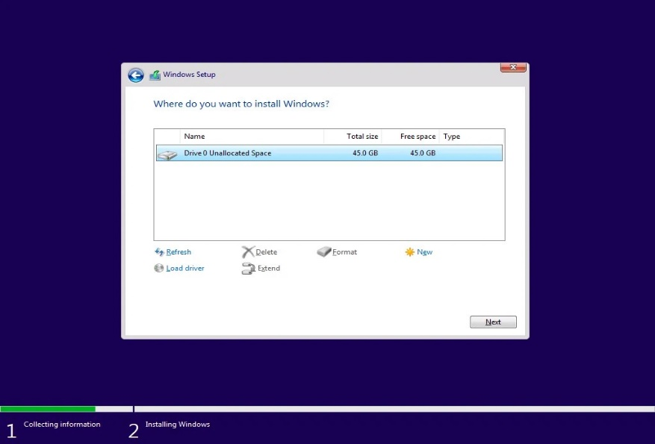

* 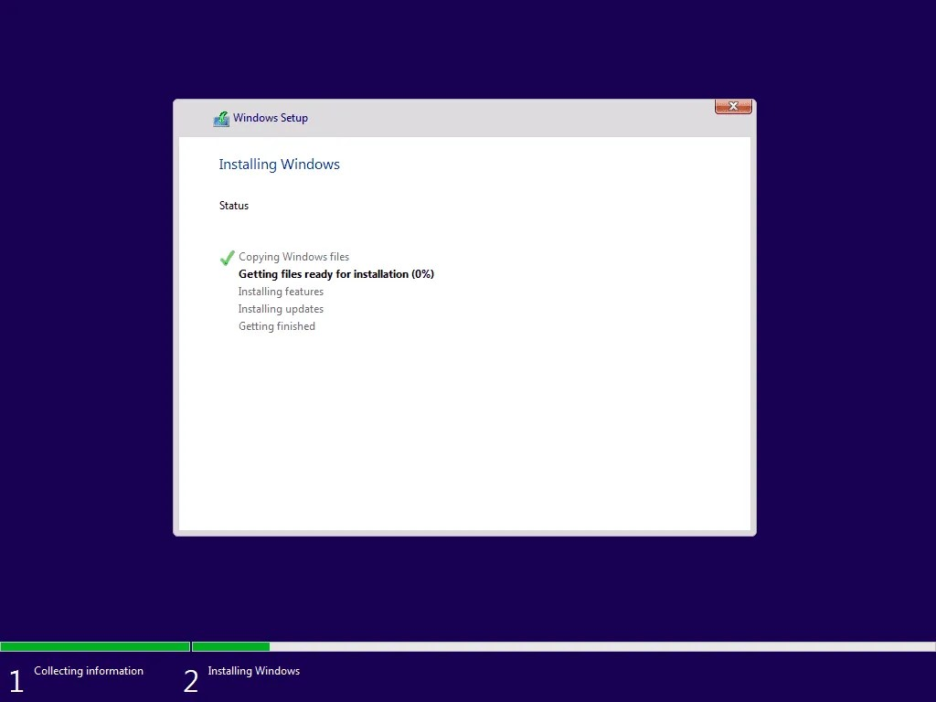Wait for the installation to complete the first steps to install Windows 10 to a new hard drive. This step will take a while.
* When the installation steps are completed, your PC will display a restart notification countdown. To restart immediately, click **Restart now**. See the second image below.

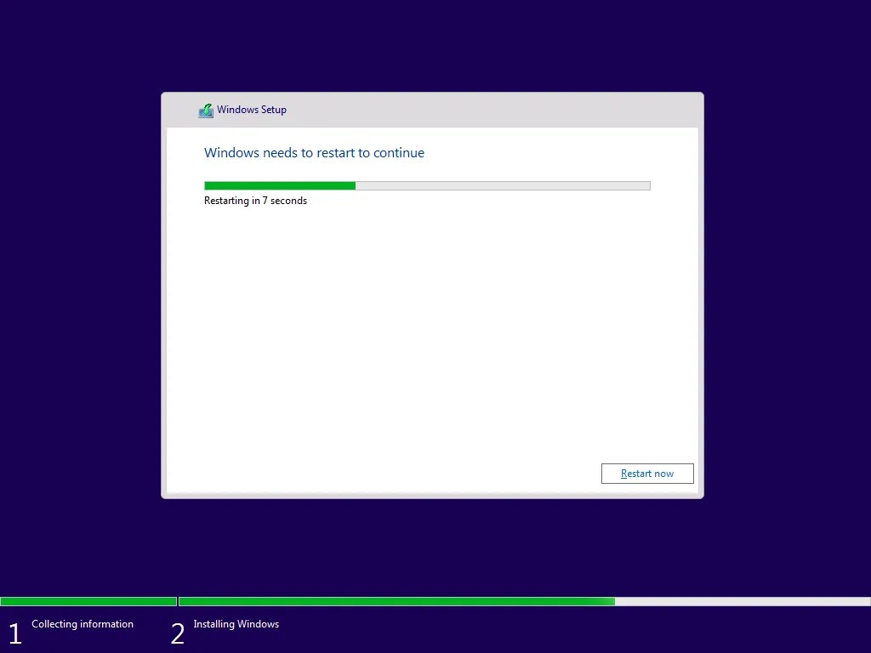

* The restart will take a while. Then your PC will display the following screens. It may stay on the **Getting ready** screen for a while. After the Getting ready screen, your PC will restart again.

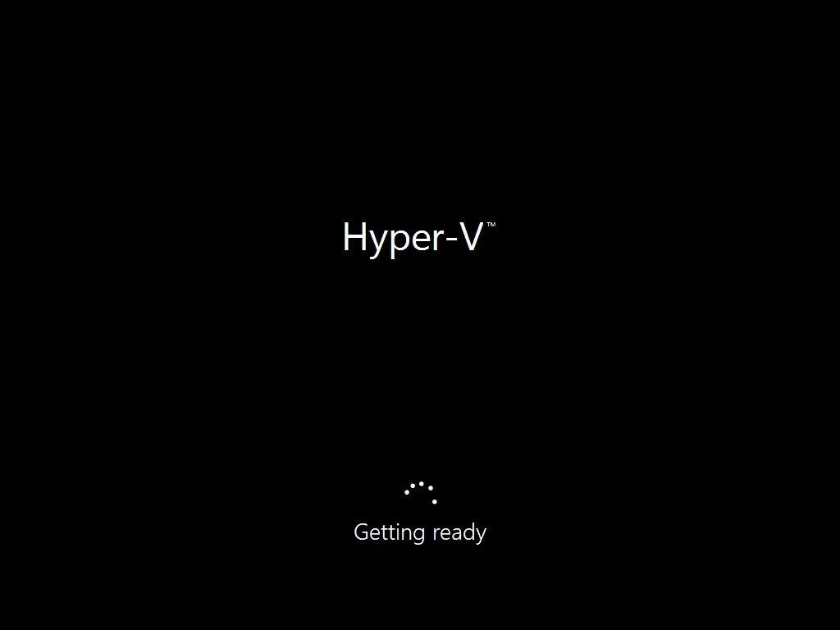

1. Complete the Final Steps to Install Windows 10 on a New Hard Drive

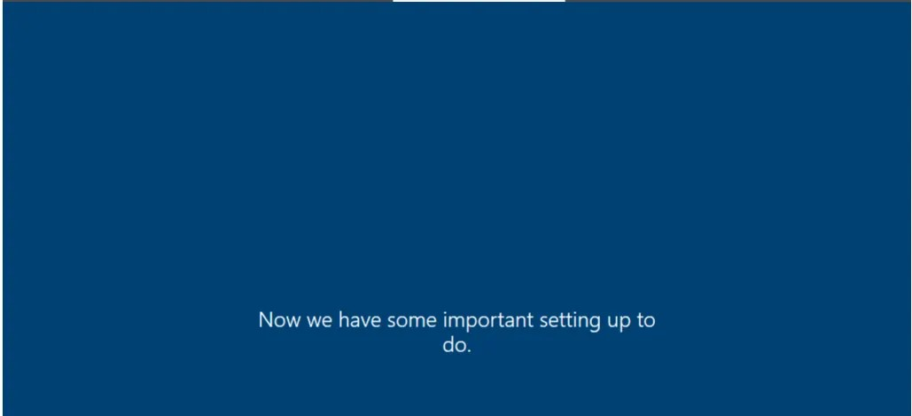

* When your computer restarts, follow these steps to complete the final steps to install Windows 10 on a hard drive:
* Check that your region is correct. Then click **Yes** to continue. Otherwise, select your region and click **Yes**.

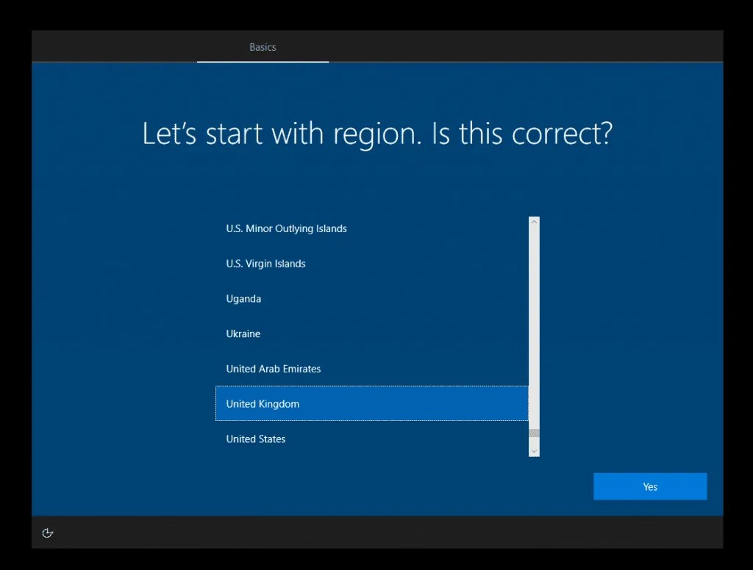

* Then confirm that your keyboard is correct and click *Yes*. Or select a new keyboard.
* At the option to add a second keyboard, to add a new keyboard click **Add layout**. Otherwise, click **Skip**.

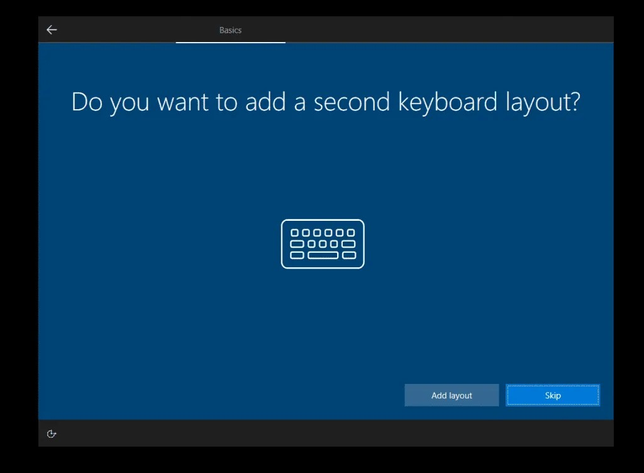

* 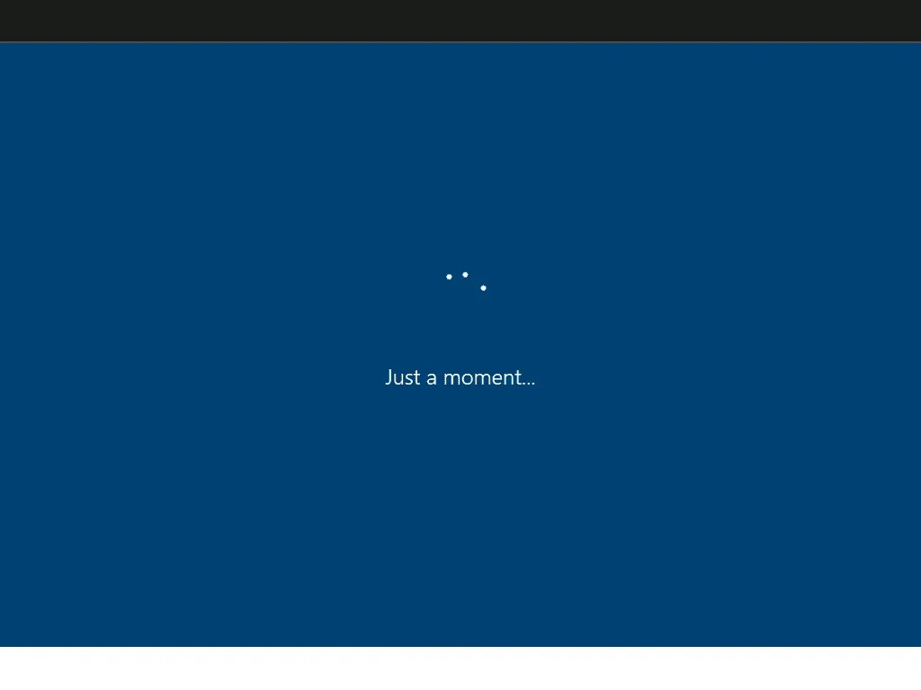Then wait for the next screen to load…
* The installer will begin configuring some additional setups.

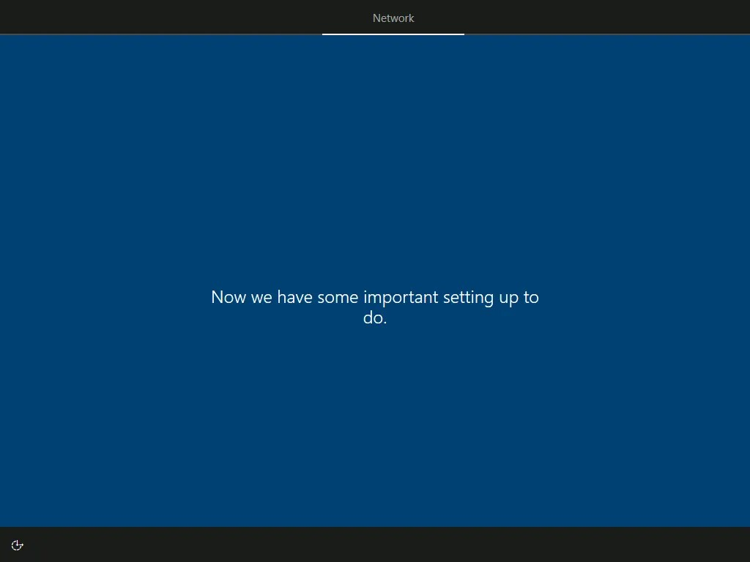

* Then you will be offered the option to choose whether you are installing Windows for personal use or for a company. Select an option and click Next. For this demo, I will select **Setup for personal use**.

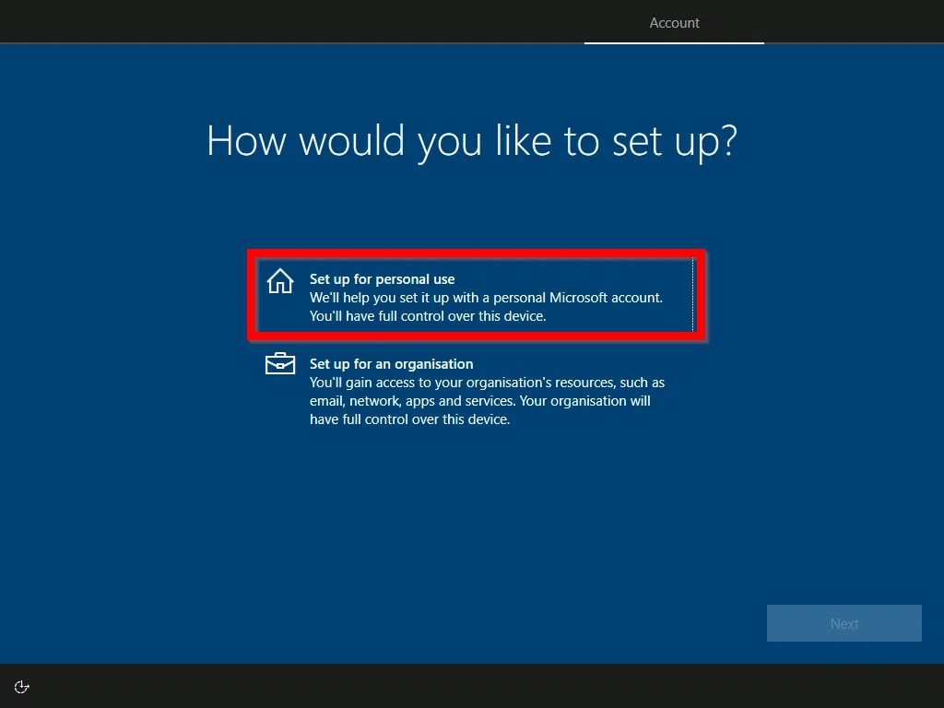

* At the **Sign in with Microsoft** screen, enter your Microsoft account. Then click Next.

You can sign in with a Skype, Outlook.com, Live, Xbox or any other Microsoft account. If you prefer to sign in with a local account, click **Offline account**.

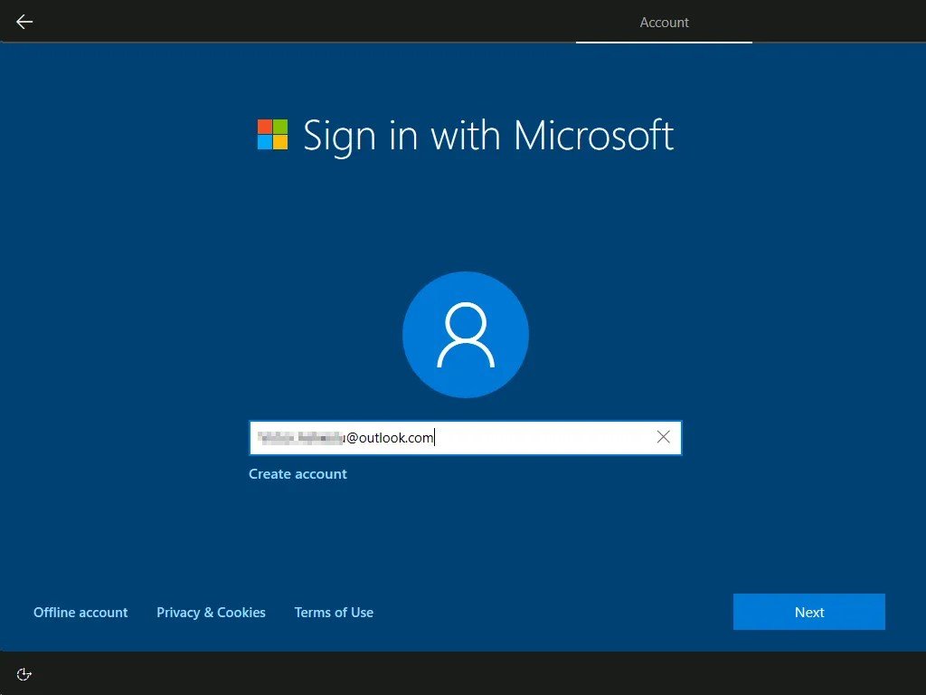

* Then type the password for your Microsoft account and click Next.

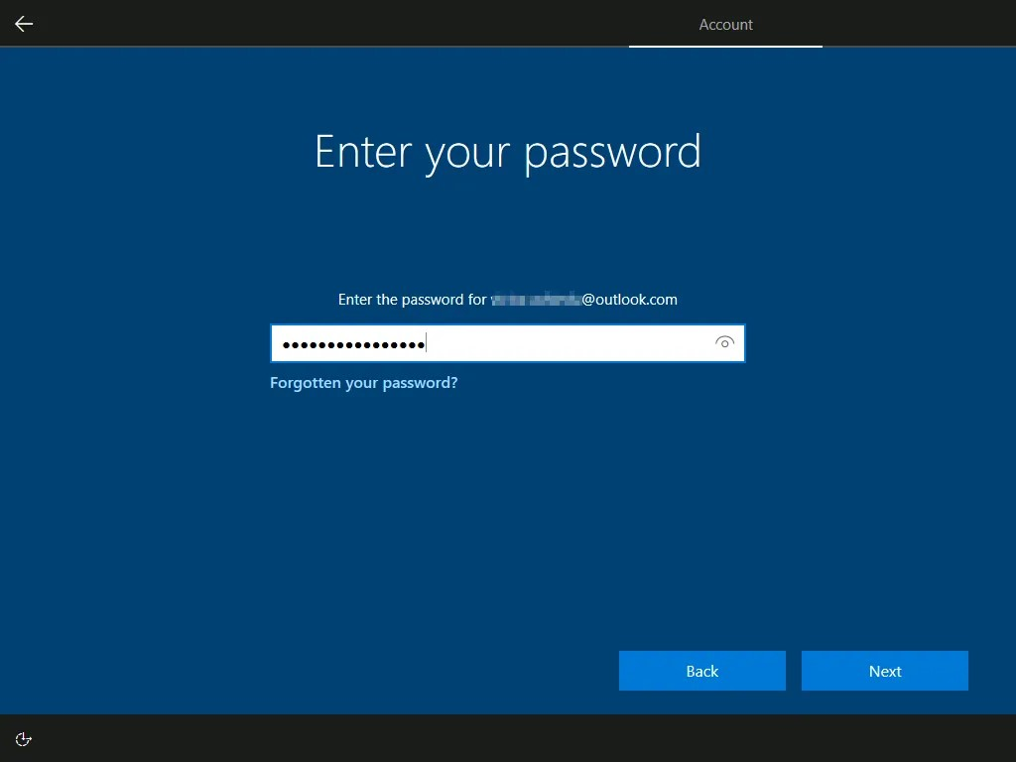

* On the **Create a PIN** screen, click **Create PIN**.

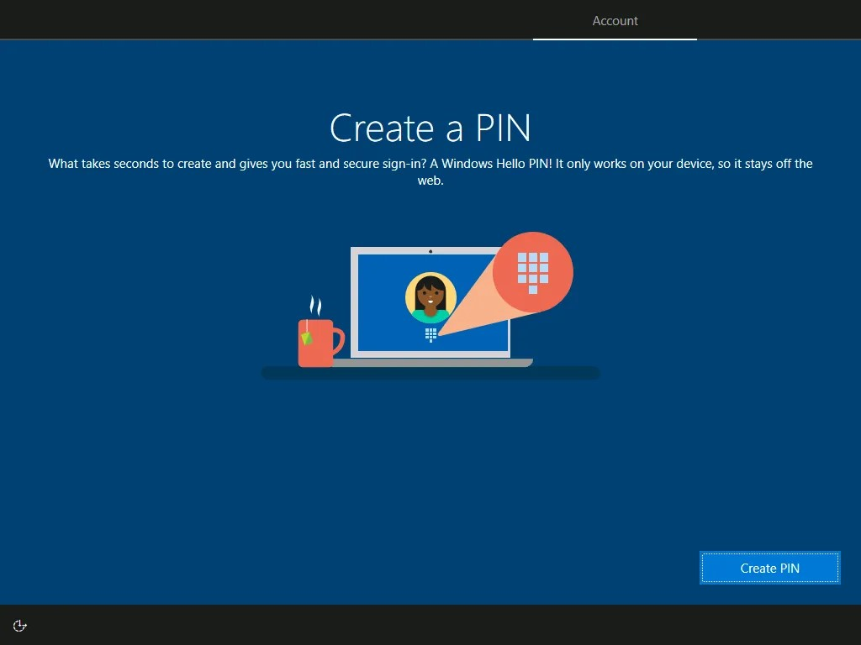

* If you require this service configure it. Otherwise, click **Do it later**.

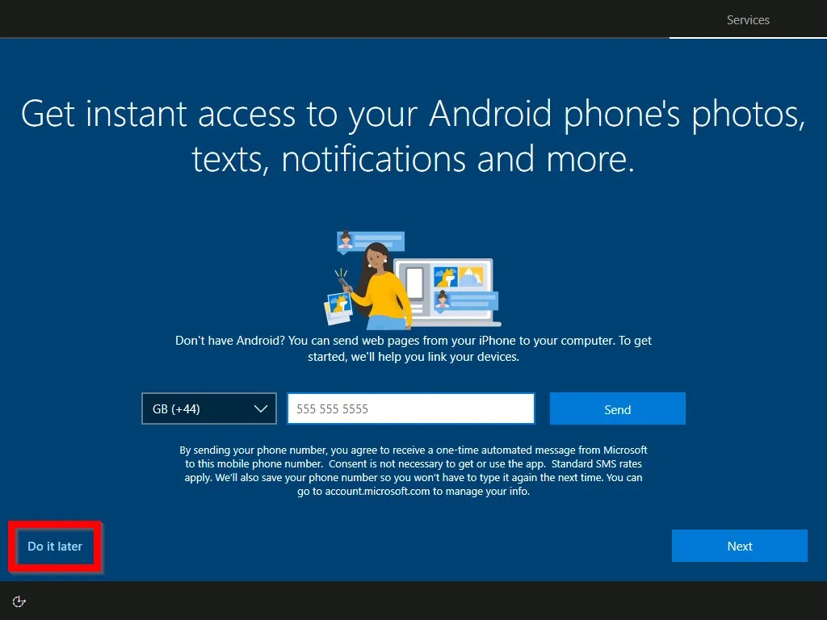

* Then, on the **Back up your files with OneDrive** screen click **Only save files to this PC**.

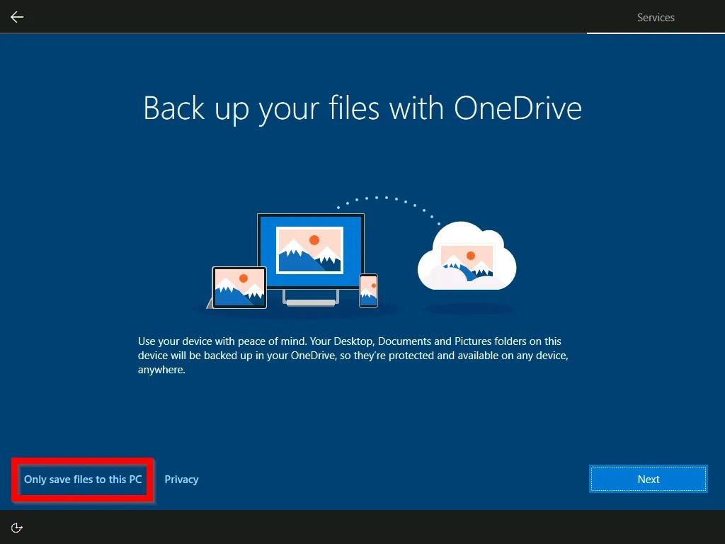

* Finally, on the next set of screens, configure various privacy options including Cortana. For most of the screens, select an option then click Yes or No…or Accept or Decline… After making your selections, the installer will perform some final configurations…Then you will be automatically signed in.

